Call to Order – Jennifer Gibson

Jennifer welcomed all members to the January membership meeting.

Officer Reports

Recording Secretary – Christie Webb
A motion was made, seconded, and approved to accept the December 2021 membership minutes.

President – Jennifer Gibson

Happy New Year everyone! The 2021-2022 Junior Guild year has continued virtually through Zoom calls.

Thank you to everyone who could make it to our December dinner meeting! I enjoyed seeing everyone in person and meeting our new Provisional class. We will be having our straw ballot to be sent at the end of the meeting after discussed in new business. The ballots will go out in a Google form and members can cast their vote for nominating committee as well as ways and means. Each member will only be allowed to vote once via e-mail, we will discuss the process during new business. The nominating committee will reach out to those who have been nominated for Ways and Means and will announce the winners at our February meeting.

Volunteer Opportunities are continuing to be scheduled on Track-it-forward, I know there is a community service opportunity coming up on the 23rd for roadside cleanup. Please make sure to sign up and log all of your hours, this includes the board.

Treasurer – Keyana Walston

Admin: $27,009.72
Fundraising: $5,655.68
Discretionary: $9,040.33

Corresponding Secretary – Ashley Newman

A congratulations card was mailed to Emily Batchelor on the birth of her son
(December 28th ,2022).

Past President/Parliamentarian – Haven Weston

This year’s Constitution Review Committee members include:

Alex Gilman
Christie Webb
Maria Newcomb
Kaila Billups

Thank you ladies for taking the initiative and time to join this committee, we will be meeting on Wednesday, January 19th at 6:00pm to discuss potential changes, additions or revisions and will then present to the Board and Membership in February, allow for thoughts and ideas, edit, then bring to the March meetings for approval.

Standing Committee Reports

Fundraising – Heather Jones/Kaila Billups

The 18th Annual Bargain Sale will take place on Saturday March 5th from 7am-12pm at the Nash County Farmers Market. Admission will be $2. A flyer has been created and will be sent to the membership soon along with emails regarding details of the sale.
We are super excited and pumped for this year’s Bargain Sale!
An email was sent to the Ways and Means committee to see if we can get 850 mums approved for next year so Bass Plant Farm can be notified.

Communications – Sherri Bryant

If you have anything to be included in the Winter newsletter, please send to sherribryant11@gmail.com with a subject line JG Newsletter.

Final edits to the handbook are underway.

Please let PJ Roberson or Sherri know if you have anything that you need updated or posted to our website or social media pages.

Community Service/Projects – Alexandra Gillman/Ann Catherine Phillips

After taking a little bit of a slowdown for the holidays, the committee is moving full steam ahead to nail down a spring service and project schedule. Committee will be meeting later next week to firm up dates for a day at the soup kitchen and looking into potential dates for partnering with Meals on Wheels. Once the committee has met, we’ll firm up details for Backpack Buddies.

We do have roadside cleanup scheduled for Sunday, Jan 23. Right now, there are a lot of registered volunteers - we may look into splitting those volunteers up to a second location. More to come on that.

And, as a friendly reminder - be on the lookout for information being shared soon for service opportunities to support Tackle the Tar.

Cultural & Social – Keyana Walston

We want to thank everyone for an awesome December dinner meeting! We hope everyone who attended enjoyed the 360 photo booth. Due to the increase in COVID cases we will not host a pop social event for January or February.

Placements – Lizzy Clapsadl

We have logged 498.5 hours so far! That is up 60 hours from last month!
Our top 3 are:

1. Alexandra Gilman at 52.5 hours
2. Heather Jones at 47.5 hours
3. Haven Weston at 44 hours

Our top 3 non board members are:

1. Ann Catherine Phillips – 22 hours
2. Jessica Poindexter – 19 hours
3. Janee Harris – 18.5 hours

There are 6 members who haven’t logged any hours, so make sure you’re keeping track and if you have an issue, please get with me, Jennifer, or your committee chair. We are here to help! 4 hours a month is ideal to get to 36 hours, so 16 would be on track. Some people have more in the spring and others more in the fall, just recognize where you are.

Provisionals – Melanie Townsend & Nickie Rich

No report.

Puppets – Diana Norville & Ashley Newman

We are going to be recording the show this Saturday morning at the Imperial Center. If anyone can come join us, we will be meeting there at 10:00 AM. Also, please be aware-this is the last meeting before our first show on February 4th at 10:15AM. We have a sign-up sheet that will be sent out through google forms. We would like to have three people for each show, but two will work. Remember, the show will have been prerecorded so you will NOT need to know the script. You will only be moving the mouth of the puppet. The script will be provided, you will only need to follow along. Please, please, please sign up! This will count towards your hours for the year. We have had a few schools reach out already, so the excitement is happening! We look forward to our puppet show this year and bringing smiles to the kids (and adults) faces.

Scholarship – Tiffany Delano

December Closing Balance: $459,198.31

3 out of 4 checks have been written for Spring 2022 Semester.
Waiting on Meredith Sides' last grade report.
Starting on 2022 Application.

Please advise if you would like to be on the Scholarship Committee.
Applications will be reviewed around April.

Account History and Performance

The account was opened in March 2003 with a beginning balance of $148,500.00
There have been 3 deposits in the amount of $10,000 each added to the account on August 2008, August 2009, May 2010.
Disbursements have totaled $114,000.00 since 2003.
Current market value of the account is $444,824.00, as of Nov 27, 2021.
Below are the disbursements shown in detail for each year.
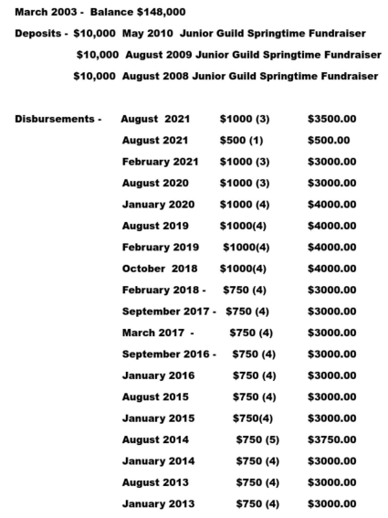
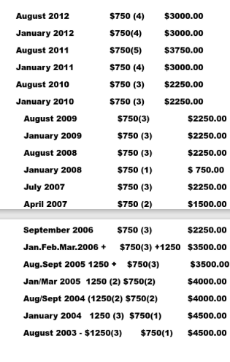
Community Trust – Maria Newcomb

No report.

Old Business

No report.

New Business

A straw ballot will be sent out via email to indicate your nominations for both the Nominating Committee and the Ways & Means Committee.

Announcements
No report.

Closing

The next membership meeting will be held via Zoom on Thursday, 02/03/2022 at 6:45pm.

Meeting adjourned by President, Jennifer Gibson.

Respectfully submitted,

Christie Webb, 2021-2022 Recording Secretary

Jennifer Gibson, 2021-2022 Junior Guild President

